
Investigation
Year 7 Science

Experiment

Purpose:
To investigate how various surfaces affect the size of the friction force an object experiences.

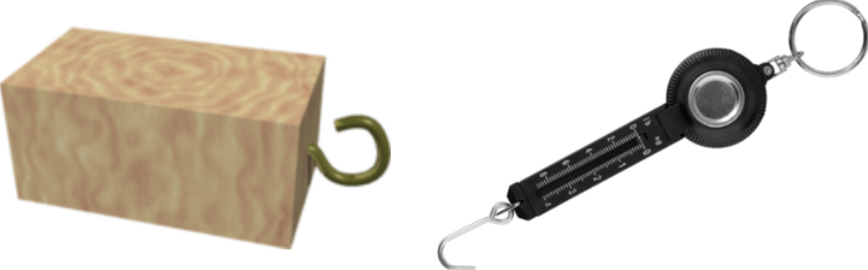
Materials

• 1 x Wooden block with a hook in one end
• 1 x Spring balance that can hook onto the wooden block
• Several different surfaces to drag the block along

Procedure

1) Hook the spring balance onto the wooden block.

2) By holding onto the spring balance, pull the block across the first surface at a constant speed.

3) Record the force value (in newtons, N) displayed on the spring balance.

4) Repeat steps 1-3 at least twice.

5) Now repeat steps 1-4 for each surface.

Title: Investigating Friction and Surfaces

Aim:

Variables: List each of the relevant variables for your investigation.
Independent variable: State the variable that you are changing in the investigation.
Dependent variable: State the variable that you are measuring or finding out.
Controlled variables: Lists the variables that you need to keep the same in the investigation. State how you are going to control each variable (MINIMUM 3)

Hypothesis: If the independent variable is changed then something will happen to the dependent variable

Materials: List all the materials that you will need to be able to conduct the investigation

Method: Write each step that you did to complete the investigation.

What are the steps you will follow to complete the investigation? ( You need to delete this text when you are done)
The method:
- is written in numbered steps
- is written in third person and past tense
- clearly changes the independent variable
- accurately measures the dependent variable
- controls all other variables
- includes detailed steps

Results: Organise your data in a results table.

 | [Dependent Variable]
Independent Variable: | Trial 1 | Trial 2 | Trial 3 | Average

Graph: Graph the average of your results. This may be on graph paper, or digital.

The graph:
- has a title that includes both the IV and the DV
- has the IV on the X-axis and the DV on the Y-axis
- has both axes labelled, including units
- is a line graph if my data is continuous or a column graph if my data is discrete
- has scales that increase in even amounts

- is plotted accurately
Discussion: State the trend between the independent and dependent variables. Use your scientific understanding to explain the reason for the trend.

Do your results agree with your hypothesis?
What was the trend or pattern between the variables?
As the (independent variable) (describe how it changes), the (dependent variable) (describe how it changed).
Try and suggest a scientific reason for this pattern or trend?

Evaluation: Reflect on your investigation and identify what worked well and what you could improve..

Conclusion: Write one paragraph:
- explaining whether your results support your hypothesis.
- State the most important outcome of the investigation
.

Marking Key

Title | Marks
- Full sentence  - Accurately describes what the investigation is about | / 1

Aim | Marks
- Clear and concise  - Explains The purpose of the investigation | / 1

Variables | Marks
Independent Variable:  - Stated correctly | / 1
Dependent Variable:  - Stated correctly | / 1
Control Variables:  - 3 x valid controls | / 3

Hypothesis | Marks
- Uses correct format  - Clear link between independent and dependent variable | / 2

Materials | Marks
- Comprehensive list of all materials used in the investigation  - Written in bullet point format | / 2

Method | Marks
- Written in numbered steps  - Third person, past tense  - Steps are concise, easy to follow and accurate  - The method clearly changes the independent variable  - The method clearly measures the dependent variable  - The method controls all other variables | / 3

Results | Marks
- The table has the independent variable in the first column and the dependent variable in the other columns  - Headings included with units  - The table includes averages | / 3

Graph | Marks
- Title that includes the independent and dependent variables  - Independent variable is on the X-axis & Dependent variable is on the Y-axis  - Label and units on axis  - Scale increases in even increments  - Correct graph type (continuous data = line graph; discrete data = column graph)  - Data plotted correctly | / 6

Discussion | Marks
- The trend between the variables has been described  - A scientific reason for the results is explained | / 3

Evaluation | Marks
- Identify what worked well in the investigation  - Identify what could be improved in the investigation . | / 2

Conclusion | Marks
- The conclusion summarises the most important outcome of the investigation  - The conclusions states whether the outcome supports the hypothesis or not | / 2

Report Format | Marks
- The report is written in an appropriate manner with formal language  - The report contains few spelling or grammatical errors | / 2

Total | Marks
 | / 32

